11.99: a) From Eq.(11.10),
to two figures. b) c) The magnitude will be vary with distance; the average force is 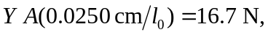and so the work done by the applied force is d) The wire is initially stretched a distance 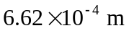( the result of part (a)), and so the average elongation during the additional stretching is 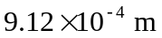, and the average force the wire exerts is 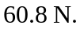The work done is negative, and equal to
e) See problem 11.82. The change in elastic potential energy is
the negative of the result of part (d). (If more figures are kept in the intermediate calculations, the agreement is exact.)

